After installing Vagrant, you can navigate to a folder using PowerShell and manage your environment with the following commands:

* **vagrant init:** Creates a Vagrantfile in the current directory. This file contains the configuration of your virtual machine.
* **vagrant up:** Starts the virtual machine defined in the Vagrantfile, or creates it if it doesn't exist. Also handles setup and provisioning.
* **vagrant ssh:** Connects to the virtual machine via SSH. (May not work with Windows VMs.)
* **vagrant halt:** Safely shuts down the virtual machine.
* **vagrant suspend:** Suspends the VM (saves RAM state for quick resume).
* **vagrant resume:** Resumes a suspended VM from where it left off.
* **vagrant destroy:** Completely removes the VM, including disk files.
* **vagrant reload:** Restarts the VM and applies any changes made to the Vagrantfile.
* **vagrant provision:** Manually runs the provision scripts (e.g., shell, Ansible) defined in the Vagrantfile.
* **vagrant box add:** Adds a new box (base VM image). Example: vagrant box add ubuntu/focal64
* **vagrant box list:** Lists all boxes installed on your system.
* **vagrant box remove:** Removes a specific box from your system.
* **vagrant status:** Shows the status of the Vagrant VM.
* **vagrant global-status:** Shows the status of all Vagrant machines on your system.
* **vagrant version:** Displays the installed Vagrant version.
* **vagrant plugin install <plugin>:** Installs a specified Vagrant plugin.

With the above commands, you can create virtual machines using Vagrant, automate their setup, and connect to them via RDP or SSH. However, it's important to note that some plugins are designed specifically for certain operating systems, and may not work properly or at all on others. For example, in the case of the vagrant-qemu plugin, you can manually edit the configuration files located at: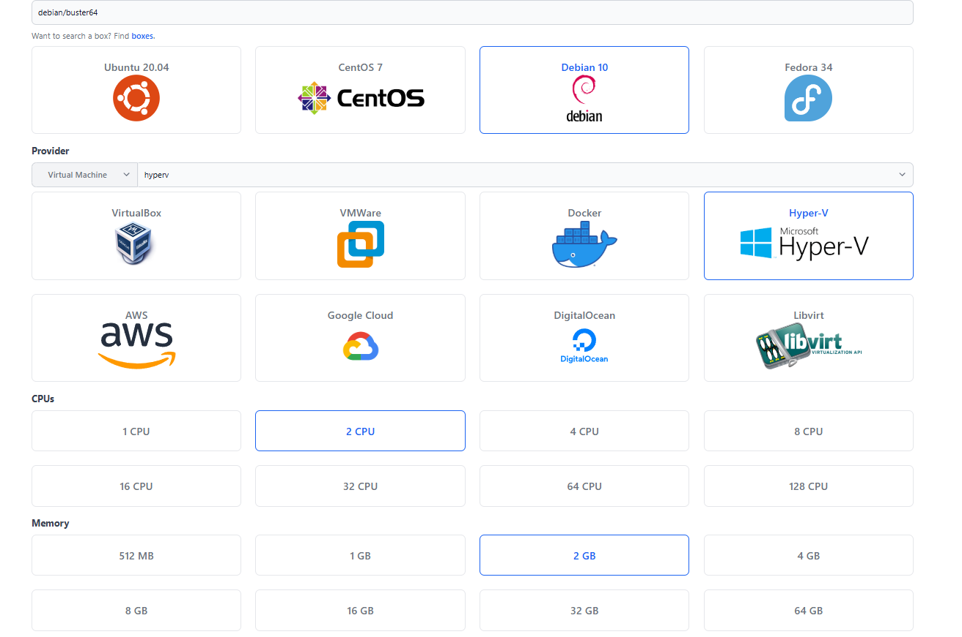

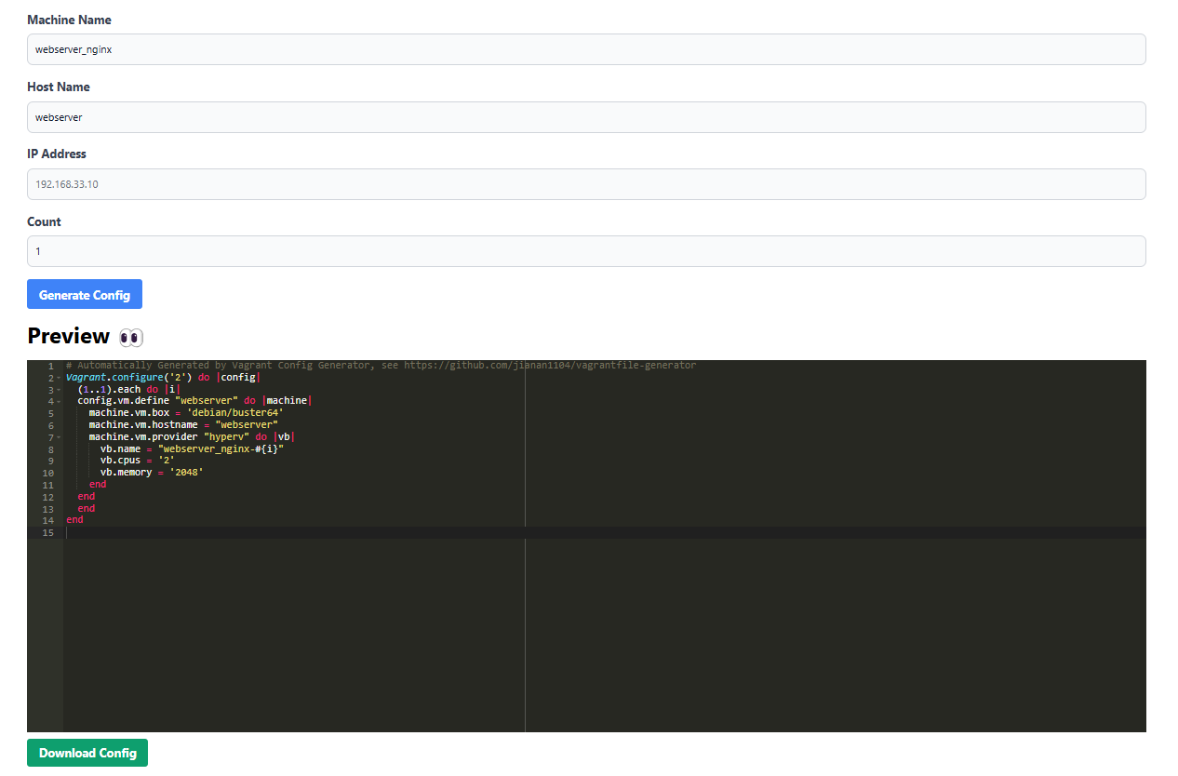

And after completing these steps, it's enough to open PowerShell with administrator privileges in the folder where the Vagrantfile is located and run “vagrant up”. Vagrant will automatically create the virtual machine from scratch. Once the VM is created, you can connect to it using Remote Desktop with “vagrant rdp”, or access the server via SSH using “vagrant ssh”.